City of Fort Bragg, California

Fire Impact Fees Report
Fiscal Year Ended June 30, 2024



Prepared by City of Fort Bragg

For purpose of compliance with California Government Code Subsection 66013(d), the following information regarding Impact Charges is presented in connection with the City’s Fire Impact Fees fund:

- A description of the charges deposited in the fund.

Capacity Fees - Capacity charges collected are used for the planning, design, construction or support activities of facilities in existence at the time the charge is imposed or for new facilities to be constructed in the future that are of reasonable benefit to the person(s) being charged.

FY 2024:

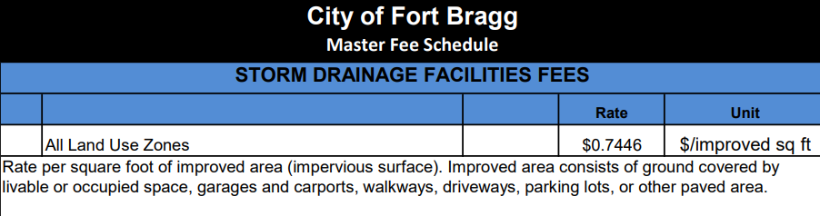

(2) The amount of charges collected in that fiscal year. See the statement below.

Statement of Revenues, Expenditures, and Changes in Fund Balance

(4) An identification of all of the following:
- Each public improvement on which charges were expended and the amount of the expenditure for each improvement, including the percentage of the total cost of the public improvement that was funded with those charges if more than one source of funding was used.
- Each public improvement on which charges were expended that was completed during that fiscal year.

Storm Drain Fees of $806.60 were expended as part of the trash capture device project awarded in November 2024.
- Each public improvement that is anticipated to be undertaken in the following fiscal year.

- A description of each interfund transfer or loan made from the account or fund, including the public improvement on which the transferred or loaned fees will be expended, and, in the case of an interfund loan, the date on which the loan will be repaid and the rate of interest that the account or fund will receive on the loan.

(5) A description of each interfund transfer or loan made from the capital facilities fund. In the case of an inter-fund transfer, the information provided shall identify the public improvements on which the transferred money are, or will be, expended. In the case of an interfund loan, the information shall include the date on which the loan will be repaid and the rate of interest that the fund will receive on the loan.

No interfund transfers or loans were made during the fiscal year utilizing these funds.

